Christ, the King of the Universe: 11/20/22—9:30 and 11:30 AM
I don’t know how many of you know this, but Fr. Mark and I regularly go to St. Joseph’s Hospital here in St. Charles and celebrate the Sacrament of the Sick with patients there. One of my days to anoint is Sunday. Last Sunday, I had to anoint a couple of people in the behavioral health unit, and that unit must have some sort of music therapy program they do on late Sunday mornings because most of the patients are gathered in one room along with a staff member who is playing recorded music. What caught my attention when I was there last Sunday was one of the songs they played was the BeeGees song How Deep Is Your Love?, one of my favorites. Because it is one of my favorites, it became an earworm for me last Sunday which I hummed all day. As you may remember, its refrain goes like this: How deep is your love? How deep is your love? How deep is your love? I really mean to learn--'Cause we're living in a world of fools--Breaking us down when they all should let us be--We belong to you and me. In fact, I have been humming those words all week. Today’s feast of Christ the King asks us to consider: how deep is your love, in other words, how deep is our love, how deep is my love, for the One whose love was so great that he died on a cross for us, that he died on a cross for me?
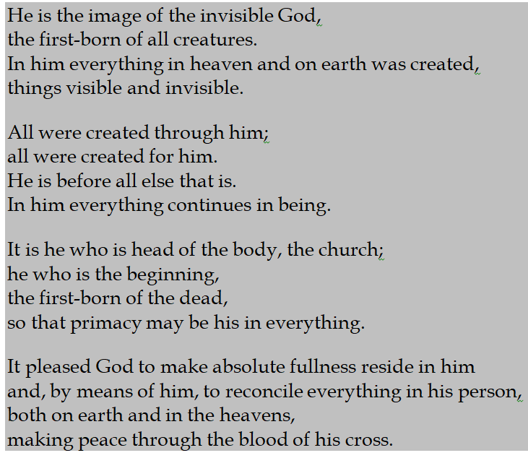
St. Paul’s words today in his letter to the Colossians help us to reflect on just who Jesus was and how great his love for us in dying on that cross is when he describes him in these words that are really a song themselves. When I was at Assumption in O’Fallon, the Precious Blood Sisters would sing these words every Wednesday evening at Mass. I was transferred from Assumption in 1985, but the singing of these words is also an earworm for me since that time, like those BeeGees lyrics, words that go like this …… This is who Jesus was, and this is who Jesus continues to be.
This past Thursday was the inauguration of the new soccer stadium in downtown St. Louis, and I am sure that there was a lot of cheering going on down there. There is a lot of cheering at soccer games, a lot of cheering at Cardinal baseball games, a lot of cheering at Blues hockey games, a lot of cheering at Billikens basketball games, a lot of cheering at Kansas City Chiefs football games, but how often do we cheer Jesus? Isn’t the way we sing at Mass to be a form of cheering? Isn’t the sincerity with which we pray at Mass to be a form of cheering? Isn’t our attentiveness to the Readings and to the words the priest prays in our behalf at Mass to be a form of cheering? Yes, to all three of these questions, but I think that the best and most full-throated form of our cheering of Jesus is how much we let him influence our lives. Again the BeeGees sing “How deep is your love.” If our love for Jesus was really, really deep, how could we live in any other way than to let Jesus influence everything we do? But the BeeGees also sing in that same refrain, “we’re living in a world of fools.” How easy it is to be a fool as we let our priorities get all out of whack in so many ways. Who are the fools but us, you and me, when we let our love for Jesus become shallow rather than letting it deepen every day?

