Pentecost Sunday: 6/5/22—9:30 and 11:30 AM
As you know, this weekend, we are celebrating the Feast of Pentecost focusing on the importance of the Holy Spirit to the Church as well as focusing on the effects of the Holy Spirit on the Church. I have two items here which I think can help us to appreciate both: a pack of cigarettes and a 64-count box of Crayola Crayons.
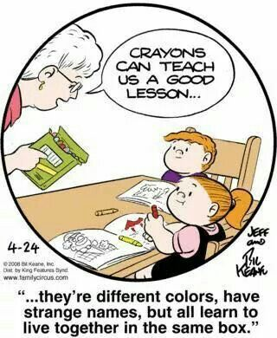
First, the pack of cigarettes. Did you ever notice how whenever the Holy Spirit is described, it is usually portrayed as “wind” and “breath”? We find it to be so in this very familiar reading today from the Acts of the Apostles, Suddenly there came from the sky a noise like a strong driving wind, and it filled the entire house in which they were. Or today’s reading from St. John’s Gospel, “As the Father has sent me, so I send you.” And when he had said this, he breathed on them and said to them, “Receive the Holy Spirit.” Just as much as we need breath and wind to live physically, so we need the breath and power of the Holy Spirit to live spiritually. So where does this pack of cigarettes come in? I remember it being said that smoking cigarettes is “a slow form of suicide.” The question for each one of us is: where am I trying to find life-giving breath? If we are looking to find value, meaning, and truth in other ways than through the Holy Spirit, we are most likely pursuing “a slow form of suicide.”
Second, this 64-count box of Crayola Crayons. Some years ago, I remember reading a “Family Circus” comic in the Post-Dispatch where Grandma is speaking to two of her grandchildren. Holding a box of crayons, she says……. And there are all sorts of strange names in this box, names like “mulberry,” “orchid,” “apricot,” “burnt sienna,” “thistle,” “cornflower,” “sepia,” and the like, but they all live in this same box. St. Paul, in today’s reading from First Corinthians, says pretty much the same thing about the role of the Spirit when it comes to the Church, As a body is one, though it has many parts, and all the parts of the body, though many, are one body, so also Christ. For in one Spirit we were all baptized into one body, whether Jews or Greeks, slaves or free persons, and we were all given to drink of one Spirit. We are indeed very different from each other: male and female, rich and poor, liberal and conservative, old and young, from developed nations and emerging nations, plus a whole raft of different languages and skin colors. Yet the role of the Holy Spirit to make us, who are so varied and diverse, into the one living Body of Christ, helping us to “live together in the same box” that is the Church.
My hope is that each one of us will do two things today: First, it is my hope that each of us will take an inventory of our lives to see where we are trying to find life, light, and meaning because, if it isn’t in the Holy Spirt, we run the risk of pursuing “a slow form of suicide.” And, second, it is my hope that, despite our differences like this box of crayons, we will more and more turn to the Holy Spirit to help us to “live together” (more effectively) “in the same box” that is the Church.

